**MINI PROJECT**

**(2020-21)**

**VISIT OUR NATION**

**(Tourism Management System Website)**

**MID-TERM REPORT**



**Institute of Engineering & Technology**

**Submitted by-**

**Yugam**

**(181500836)**

**Prashant Chaudhary**

**(181500488)**

***Supervised By: -***

**Ms. Priya Agrawal**

Technical Trainer

**Department of Computer Engineering & Application**

**Contents**

**Certificate**

**Synopsis**

**Acknowledgement**

**Abstract**

1. **About Project**1.1 Introduction  
   1.2 Benefits  
   1.3 Abstract  
   1.4 Features  
   1.5 Applications  
   1.6 OBJECTIVE
2. **About Front End**2.1 Architecture of Front-End user  
   2.2 Software & Tools Used
3. **About Back End**3.1 MySQL’s Logical Architecture  
   3.2 Software’s and tools used
4. **Minimum Hardware Specification**4.1 Hardware Requirement  
   4.2 Software Requirement
5. **Software Development Process**5.1 Life Cycle Used to develop this Project  
   5.2 Our portfolio of services includes  
   5.3 Benefits of using our travel management services
6. **Screen Shots of Project**

**Certificate**

This is to certify that Yugam And Prashant Chaudhary students of B.Tech (CSE) 3rd year has successfully Completed the **MINI PROJECT** named **VISIT OUR NATION** on Web Development under the Guidance of **Ms.** **Priya Agarwal Mam** During 2020-21.

Signature:

**Ms. Priya Agarwal Mam**

(Mentor)



**Third Year Project Synopsis**

**B.Tech. (CSE)-Session 2020-2021**

**PROJECT TOPIC: VISIT OUR NATION**

**Project Group Members:**

1. Yugam (181500836)
2. Prashant Chaudhary (181500488)

**Project Mentor:** Priya Agarwal Mam (Technical Trainer)

**About the Project:** This is the website built to empower the traveler and enhance the tourist in India, With the help of this website tourists are able to find better destination for their trips very easily, our motive is to provide best Hotels, Restaurants, Monuments, Transportation Services, etc. all over the India .It contains selected and popular destinations of country. We also suggest best hotels at low prices with respected our destination with all convenience which we select for our trip. We also adding the information of best beaches, hill stations and Mountains for destination in World wide. And adding location to all the destination.

The project using the technologies of web development.

**Motivation:** We have idea of this website when we see people around us who want to travel India but they don’t have an idea where they have great fun and experiences. So, this website helps them to choose better places for their destination. And also know them estimate related to that destination.

**Project Planning:** In the starting we will collect all the raw data of best destinations and then we will arrange in best way.

The description of our work is as follows: -

|  |  |  |  |
| --- | --- | --- | --- |
| Month  work | August | September | October |
| Work on frontend with PHP,HTML, CSS |  |  |  |
| Learn JAVASCRIPT to complete the frontend part |  |  |  |
| Learn MySQL for backend purpose |  |  |  |

**Tools required:**

* **Hardware Requirements:** Computer - 2 GHz minimum, multi-core processor

Memory (RAM) - At least 4 GB

Hard disk space – At least 6 GB

* **Software Requirements:** We use many languages for our website like PHP,HTML, CSS, JavaScript as a front-end languages and MySQL as a backend purpose. And use VS-code for running and writing code.

**Signature of Project Guide: _____________________**

**Acknowledgment**

We have taken efforts in this project. However, it would not have been possible without the kind support and help of many Teachers. I would like to extend my sincere thanks to all of them.

We are highly indebted to Ms. Priya Agarwal Mam for his guidance and constant supervision as well as for providing necessary information regarding the project & also for his support in completing the project.

We would like to express my gratitude towards our parents & member of GLA University for their kind co-operation and encouragement which help us in completion of this project.

**Abstract**

The report presents the three tasks that is being in continuation during college time at GLA University which are listed below:

1. Understanding of the Problem objective & implication.

2. Understanding of the data & building of the model.

3. Evaluation of the model.

All these tasks have been completed successfully and results were according to expectations. All the tasks were need very systematic approach, starting from the collection of the data to the implementation of the solution and till evaluation of the System. The most challenging task was the domain knowledge, to understand the language. It is one of the major areas and really need very fundamental and conceptual knowledge of PHP, HTML, CSS, & MySQL.

**1.About Project**

**VISIT OUR NATION (Tourism Management System)**

**1.1 Introduction**

Travel and Tourism management system: This is an online project developed using Php and MySQL. The purpose of this project is to provide the complete information about the vehicles available for a tour. There are 2 different types of users. First the customer visits the site and enters the place from where to where he wishes to travel. He also provides the date as when he would like to travel. Then he sends these details to the travel and tourism agency. The employee of travel and tourism agency receives the mail and check which vehicle is available for that day and reverts back to the customer along with the quotation. If the customer agrees for any one of the quotation, he can reply back along with agreed quotation. Then the agency will take down all the details of the customer and will send a confirmation message to the customer. On the day of the tour, the customer first must show the confirmation message to the driver for clarity and only then he will agree to drive after looking at the confirmation message. This software is user friendly and helps in finding the vehicle sooner rather than wandering manually everywhere to find for vehicles. Before the tour starts, half payment has to be done. After the customer returns or reaches his final destination, he must pay full amount either through cash or through cards. After the travelling the customer can come back to the site and enter his feedback about the travel and tourism agency. If any good feedback will be taken positively and if any negative feedback too will be taken positively and try to improve what had lacked. The report is also generated periodically and the database will be cleared according to the time span for faster performance.  
Travel and Tourism sample code is available in the below link directed. If you would like to purchase the exact code,, mail us. A quotation will be sent. A complete support will be provided by our team to you after the purchase.

The Travel Management System team is currently developing and implementing an enterprise-wide travel system to replace the TAPS system. This system will be used for all Indiana University faculty, staff, and students to submit travel authorization documents and initiate reimbursement requests. The new system will allow for the automation of travel approvals and processing of reimbursement requests.

Currently, Travel Office staff manually enter travel authorization and reimbursement data. The system is slow and inefficient and leads to data entry errors and delays in processing travel reimbursements for IU faculty, staff, and students. The new system will speed up processing time and provide more accurate data.

The Travel Management System will be rolled out in stages. Currently, work is being completed on the back-office portion of the applications, which facilitates processing of requests and reimbursements and provides key integration points with travel vendors such as Expedia and Enterprise. The next phase of the Travel Management System project is to distribute the travel request and reimbursement forms to select departments as a pilot group. Upon successful completion of the pilot, these documents will be integrated with Kuali Enterprise Workflow (KEW) in order to accommodate electronic routing and approval. Once automated routing and approval are ready, the Travel Management System documents will be made available to all IU faculty, staff, and students.

This project development a website for Tour & Travel management system with HTML-5, CSS 3, PHP as front-end & MYSQL EXPRESS as back-end. Tour & Travel management system planning the tour for their customer. It is an application which decreases few efforts of planning of trip or making of yours holidays happy. This system provides better services for booking tickets (train, air, etc.…) & planning for visiting places & hotels facility & transportation mode.

a) Date of Donation of blood

b) validity of Blood

c) Available Blood group

**1.2 Benefits**

* Faster processing time and more accurate data for travel requests and reimbursements
* Ability for travelers to track authorization and reimbursement request status through the system rather than via phone calls or campus mail
* Major technological upgrades to the current travel system
* Use of IU's standardized, virtual J2EE environments
* Many new features and enhancements

**1.3 Abstract:**

The importance of information and efficient information management is steadily increasing due to the evolution of new technologies and high-capacity storage media but also because growing market dynamics raise information needs. A marketing decision support system (MDSS) can be of particular importance as it supports organizations in collecting, storing, processing, and disseminating information, and in the decision-making process by providing forecasts and decision models (Little 1979). The following article provides insights into a successful implementation of a MDSS in tourism. Based on findings on the analysis of the system’s protocol files, it discusses the information needs in tourism management.

**1.4 Features:**

|  |  |  |
| --- | --- | --- |
|  | Tourism Website Builder is a complete Content Management System (CMS) for the travel & tourism industry that delivers the features most requested by independent tourism operators, destination marketing groups, tourism associations and travel professionals.  **1.4.1 Anyone - Anywhere - Anytime**  All functions are secure, intuitive and user friendly, and can be operated by non-technical persons at any time, from any remote location, with an Internet connection and Web browser. A high-speed Internet connection is not required.  **1.4.2 Site Design Elements:**  You control the key site design elements for your travel or DMO Website. Choose from a variety of layouts and color palettes. Or, have us create a custom design for your site.  **1.4.3** **Template-Based Publishing**  Build Web pages quickly and easily with page templates that deliver a wide range of interactive features. Each template adheres to the site design elements you have chosen and guarantees a consistency of appearance and navigation. Simply type, insert or copy & paste information into a page template and you are ready to publish. Or, create freeform pages, that automatically retain the look and feel of the site, with the built-in Page Editor.  While anyone familiar with a word processor can begin using the Tourism Website Builder content management system immediately, experienced Web Designers will appreciate the advanced features that provide direct access to edit the HTML source or copy and paste from their favorite HTML Editor.  **1.4.4** **Eliminate Outdated Site Content.**  Tourism Website Builder ensures that only current information appears on your site by allowing you to predefine the timing of content posting and automatic removal.  **Core Features.**  These Core Features are available in every installation.  Easy to learn.  Choice of site layout and color palette.  Publish in minutes with page creation templates.  Add, edit or delete pages or entire sections.  Add, delete or change text, photos, links etc.  Preview new pages before publishing.  Distribute electronic documents.  Incorporate multimedia assets: video & audio.  Establish links to other web sites & e-mail addresses.  'Print This Page' command. For printer friendly printouts.  Add & edit search engine meta tags.  Content scheduling eliminates outdated information.  Auto menu building with ability to reorder pages.  Navigation tree supports up to 3 levels of information.  Detailed Visitor Tracking. Text & graphical reports.  Scalable to meet your company's growing needs. |  |

**1.5 Applications:**  This application is built such a way that it should suits for all type of blood banks in future. So, every effort is taken to implement this project in this blood bank, on successful implementation in this blood bank, we can target other blood banks in the city.

This application consists following modules.

* **Administrator module**
* **Travels module**
* **Routes module**
* **Reservations module**
* **Testimonials module**

**1.5.1 Administrator module:**

This module provides administrator related functionality. Administrator manages all information and has access rights to add, delete, edit and view the data related to places, travels, routes, bookings, restaurants etc.

**1.5.2 Travels module:**

This module provides the details of various travel agencies. A user can select the appropriate agency depending on convenience and accessibility.

**1.5.3 Routes module:**

This module provides information related to various routes connecting sources and destinations. For each route, information such as source, destination, fare, reservation details, pick up points etc. are provides. Only administrator can add, delete, edit and manage the data. Users can only view the information.

**1.5.4 Reservations module:**

This module provides functionalities that allow a user to book tickets or cancel previously booked tickets. The module maintains the details of all reservations made so far and allows administrator to either confirm or reject the bookings.

**1.5.5 Testimonials module:**

Users of this application can post their opinions, complaints and suggestions regarding this portal and services to the administrator. Accordingly, the administrator can take various steps to act on the complaints and suggestions.

**1.6 OBJECTIVE:**

The objective of the Travel and Tourism Management System project is to develop a system that automates the processes and activities of a travel and the purpose is to design a system using which one can perform all operations related to traveling.

**2. About Front End:**

The front end is an [interface](https://en.wikipedia.org/wiki/Interface_(computer_science)) between the user and the back end. The front and back ends may be distributed amongst one or more systems.

In [network computing](https://en.wikipedia.org/wiki/Computer_network), *front end* can refer to any hardware that optimizes or protects network traffic. It is called [application front-end hardware](https://en.wikipedia.org/wiki/Denial_of_service) because it is placed on the network's outward-facing front end or boundary. Network traffic passes through the front-end hardware before entering the network.

In [compilers](https://en.wikipedia.org/wiki/Compilers), the [front end](https://en.wikipedia.org/wiki/Compilers) translates a computer programming [source code](https://en.wikipedia.org/wiki/Source_code) into an [intermediate representation](https://en.wikipedia.org/wiki/Intermediate_representation), and the back end works with the intermediate representation to produce code in a computer output language. The back end usually optimizes to produce code that runs faster. The front-end/back-end distinction can separate the [parser](https://en.wikipedia.org/wiki/Parsing) section that deals with source code and the back end that [generates code and optimizes](https://en.wikipedia.org/wiki/Code_generation_(compiler)).

These days, front-end development refers to the part of the web users interact with. In the past, web development consisted of people who worked with Photoshop and those who could code HTML and CSS. Now, developers need a handle of programs like Photoshop and be able to code not only in HTML and CSS, but also JavaScript or jQuery, which is a compiled library of JavaScript.

Most of everything you see on any website is a mixture of HTML, CSS, and JavaScript, which are all controlled by the browser. For example, if you’re using Google Chrome or Firefox, the browser is what translates all of the code in a manner for you to see and with which to interact, such as fonts, colors, drop-down menus, sliders, forms, etc. In order for all of this to work, though, there has to be something to support the front-end; this is where the backend comes into play.

**2.1 Architecture of Front-End user:**

**2.1.1 Architecture and Concepts**

The query cache plugin is implemented as a PHP extension. It is written in C and operates under the hood of PHP. During the startup of the PHP interpreter, it gets registered as a [mysqlnd](http://php.net/manual/en/book.mysqlnd.php) plugin to replace selected mysqlnd C methods. Hereby, it can change the behavior of any PHP MySQL extension ([mysqli](http://php.net/manual/en/ref.mysqli.php), [PDO_MYSQL](http://php.net/manual/en/ref.pdo-mysql.php), [mysql](http://php.net/manual/en/ref.mysql.php)) compiled to use the mysqlnd library without changing the extensions API. This makes the plugin compatible with each and every PHP MySQL application. Because existing APIs are not changed, it is almost transparent to use. Please, see the [mysqlnd plugin API description](http://php.net/manual/en/mysqlnd.plugin.php) for a discussion of the advantages of the plugin architecture and a comparison with proxy based solutions.

**2.1.2 Transparent to use**

At PHP run time PECL/mysqlnd_qc can proxy queries send from PHP ([mysqlnd](http://php.net/manual/en/book.mysqlnd.php)) to the MySQL server. It then inspects the statement string to find whether it shall cache its results. If so, result set is cached using a storage handler and further executions of the statement are served from the cache for a user-defined period. The Time to Live (TTL) of the cache entry can either be set globally or on a per statement basis.

A statement is either cached if the plugin is instructed to cache all statements globally using a or, if the query string starts with the SQL hint (*/*qc=on*/*). The plugin is capable of caching any query issued by calling appropriate API calls of any of the existing PHP MySQL extensions.

**2.1.3 Flexible storage: various storage handler**

Various storage handler are supported to offer different scopes for cache entries. Different scopes allow for different degrees in sharing cache entries among clients.

* *default* (built-in): process memory, scope: process, one or more web requests depending on PHP deployment model used
* *APC*: shared memory, scope: single server, multiple web requests
* *SQLite*: memory or file, scope: single server, multiple web requests
* *MEMCACHE*: main memory, scope: single or multiple servers, multiple web requests
* *user* (built-in): user-defined - any, scope: user-defined - any

Support for the *APC*, *SQLite* and *MEMCACHE* storage handler has to be enabled at compile time. The *default* and *user* handler are built-in. It is possible to switch between compiled-in storage handlers on a per query basis at run time. However, it is recommended to pick one storage handler and use it for all cache entries.

**2.1.4 Built-in slam defense to avoid overloading**

To avoid overload situations the cache plugin has a built-in slam defense mechanism. If a popular cache entries expires many clients using the cache entries will try to refresh the cache entry. For the duration of the refresh many clients may access the database server concurrently. In the worst case, the database server becomes overloaded and it takes more and more time to refresh the cache entry, which in turn lets more and more clients try to refresh the cache entry. To prevent this from happening the plugin has a slam defense mechanism. If slam defense is enabled and the plugin detects an expired cache entry it extends the life time of the cache entry before it refreshes the cache entry. This way other concurrent accesses to the expired cache entry are still served from the cache for a certain time. The other concurrent accesses to not trigger a concurrent refresh. Ideally, the cache entry gets refreshed by the client which extended the cache entries lifespan before other clients try to refresh the cache and potentially cause an overload situation.

**2.1.5 Unique approach to caching**

PECL/mysqlnd_qc has a unique approach to caching result sets that is superior to application-based cache solutions. Application based solutions first fetch a result set into PHP variables. Then, the PHP variables are serialized for storage in a persistent cache, and then unserialized when fetching. The mysqlnd query cache stores the raw wire protocol data sent from MySQL to PHP in its cache and replays it, if still valid, on a cache hit. This way, it saves an extra serialization step for a cache put that all application-based solutions have to do. It can store the raw wire protocol data in the cache without having to serialize into a PHP variable first and deserializing the PHP variable for storing in the cache a

**2.2 Software & Tools Used:**

**1. PHP:-**

**2.2.1 Introduction**

PHP is now officially known as “**PHP: Hypertext Preprocessor**”. It is a server-side scripting language usually written in an HTML context. Unlike an ordinary HTML page, a PHP script is not sent directly to a client by the server; instead, it is parsed by the PHP binary or module, which is server-side installed. HTML elements in the script are left alone, but PHP code is interpreted and executed. PHP code in a script can query databases, create images, read and write files, talk to remote servers – the possibilities is endless. The output from PHP code is combined with the HTML in the script and the result sent to the user’s web-browser, therefore it can never tell the user whether the web-server uses PHP or not, because the entire browser sees is HTML.

PHP’s support for Apache and MySQL further increases its popularity. Apache is now the most-used web-server in the world, and PHP can be compiled as an Apache module. MySQL is a powerful free SQL database, and PHP provides a comprehensive set of functions for working with it. The combination of Apache, MySQL and PHP is all but unbeatable.

That doesn’t mean that PHP cannot work in other environments or with other tools. In fact, PHP supports an extensive list of databases and web-servers. While in the mid-1990s it was ok to build sites, even relatively large sites, with hundreds of individual hard-coded HTML pages, today’s webmasters are making the most of the power of databases to manage their content more effectively and to personalize their sites according to individual user preferences.

***Reasons for using PHP***

There are some indisputable great reasons to work with PHP. As an open source product, PHP is well supported by a talented production team and a committed user community. Furthermore, PHP can be run on all the major operating systems with most servers.

**a)** **Learning PHP is easy** Basic is easy any interpreted language should be easy to learn. Since you are isolated from the system (no pointers to use, no memory to allocate). The other advantage that all modern interpreted languages share is good associative array constructs.

**b)** **Its Performance**

While we can build an application that serves millions of pages a day on a server, when we really look at the performance of the language it sucks. We are still orders of magnitude from real performance. Not only that, but since PHP is designed around a single process model our ability to share data structures or connection pool resources is left to native code libraries.

**c)** **The low cost**

There are many languages which are available at very less cost. There are some languages which are available at very less cost like below:

* PHP
* C
* C++ etc.

**d**) **It’s Open Source, We can modify it**

We can modify it if you need a hole in your head! Technically the point is that it’s an open source project and they release patches often. You’re point is that the community is actively working out the bugs. So, what any active language is doing this...

Unfortunately, C, C++ and Perl have all “died” at this point and will pretty much remain static at their current functionality.

**e)** **Its Portability**

C is portable; it’s just the OS bits that aren’t. A lot PHP isn’t portable to Windows since people don’t use the OS abstractions to avoid some problems.

**F) It has interfaces to a large variety of database systems**

PHP supports a large variety of the database.

**Support available**

Online Support is available for using PHP.

* **PHP Syntax**

You cannot view the PHP source code by selecting “View source” in the browser – you will only see the output from the PHP file, which is plain HTML. This is because the scripts are executed on the server before the result is sent back to the browser.

**Basic PHP Syntax**

A PHP scripting block always starts with **<?php** and ends with?**>**. A PHP scripting block can be placed anywhere in the document. On servers with shorthand support enabled you can start a scripting block with <? And end with?>. However, for maximum compatibility, we recommend that you use the standard form (<?php) rather than the shorthand form.

A PHP file normally contains HTML tags, just like an HTML file, and some PHP scripting code.

**2.2.2 HTML**

**HTML** or **Hyper Text Markup Language** is the standard markup language used to create web pages.

HTML was created in 1991 by Tim Berners-Lee at CERN in Switzerland. It was designed to allow scientists to display and share their research.

HTML is written in the form of HTML elements consisting of *tags* enclosed in angle brackets (like <html>). HTML tags most commonly come in pairs like <h1> and </h1>, although some tags represent *empty elements* and so are unpaired, for example <img>. The first tag in a pair is the *start tag*, and the second tag is the *end tag* (they are also called *opening tags* and *closing tags*).

The purpose of a web browser is to read HTML documents and compose them into visible or audible web pages. The browser does not display the HTML tags, but uses the tags to interpret the content of the page. HTML describes the structure of a website semantically along with cues for presentation, making it a markup language rather than a programming language.

HTML elements form the building blocks of all websites. HTML allows images and objects to be embedded and can be used to create interactive forms. It provides a means to create structured documents by denoting structural semantics for text such as headings, paragraphs, lists, links, quotes and other items. It can embed scripts written in languages such as Java Script which affect the behavior of HTML web pages.

HTML is descriptive markup language. Library of various markup languages is defined in various browsers.

**a) HTML Images - The <img> Tag and the Src Attribute**

In HTML, images are defined with the <img> tag.

The <img> tag is empty, which means that it contains attributes only, and has no closing tag.

To display an image on a page, you need to use the src attribute. Src stands for "source". The value of the src attribute is the URL of the image you want to display.

**Syntax for defining an image:**

<imgsrc="*url*" alt="*some_text*">

**b) HTML FORMS**

HTML forms are used to pass data to a server.

|  |
| --- |
| The <form> tag is used to create an HTML form:  <form> . *input elements* . </form> |

An HTML form can contain input elements like text fields, checkboxes, radio-buttons, submit buttons and more. A form can also contain select lists, textarea, fieldset, legend, and label elements.

**c)** **Image tag (<img>):**

To add an image to an HTML document, we just need to include an <IMG> tag with a

reference to the desired image. The <IMG> tag is an empty element i.e. it doesn’t require a

closing tag and we can use it to include from small icons to large images.

**Syntax: <imgsrc=”URL” alt=” alternative text”>**

**d) HTML Lists:**

|  |  |
| --- | --- |
| An ordered list:   * The first list item * The second list item * The third list item | An unordered list:   * List item * List item * List item |

**2.2.3 HTML 5**

HTML5 will be the new standard for HTML. The previous version of HTML, HTML 4.01,

came in 1999. The web has changed a lot since then. HTML5 is still a work in progress.

However, the major browsers support many of the new HTML5 elements and APIs.

HTML5 is cooperation between the World Wide Web Consortium (W3C) and the Web

Hypertext Application Technology Working Group (WHATWG).

WHATWG was working with web forms and applications, and W3C was working with

XHTML 2.0. In 2006, they decided to cooperate and create a new version of HTML.

Some rules for HTML5 were established:

a) New features should be based on HTML, CSS, DOM, and JavaScript

b) Reduce the need for external plug-ins (like Flash)

c) Better error handling

d) More markup to replace scripting

e) HTML5 should be device independent

f) The development process should be visible to the public

**2.2.4 CSS**

**CSS tutorial** or CSS 3 tutorial provides basic and advanced concepts of CSS technology. Our CSS tutorial is developed for beginners and professionals. The major points of CSS are given below:

* CSS stands for Cascading Style Sheet.
* CSS is used to design HTML tags.
* CSS is a widely used language on the web.
* HTML, CSS and JavaScript are used for web designing. It helps the web designers to apply style on HTML tags.

**Cascading Style Sheets** (**CSS**) is a style sheet language used for describing the look and formatting of a document written in a markup language. While most often used to style web pages and user interfaces written in HTML and XHTML, the language can be applied to any kind of XML document, including plain XML, SVG and XUL. CSS is a cornerstone specification of the web and almost all web pages use CSS style sheets to describe their presentation.

CSS is designed primarily to enable the separation of document content from document presentation, including elements such as the layout, colors, and fonts. This separation can improve content accessibility, provide more flexibility and control in the specification of presentation characteristics, enable multiple pages to share formatting, and reduce complexity and repetition in the structural content (such as by allowing for table less web design).

CSS can also allow the same markup page to be presented in different styles for different rendering methods, such as on-screen, in print, by voice (when read out by a speech-based browser or screen reader) and on Braille-based, tactile devices. It can also be used to allow the web page to display differently depending on the screen size or device on which it is being viewed. While the author of a document typically links that document to a CSS file, readers can use a different style sheet, perhaps one on their own computer, to override the one the author has specified.

With plain HTML you define the colors and sizes of text and tables throughout your pages. If

you want to change a certain element you will therefore have to work your way through the

document and change it. With CSS you define the colors and sizes in "styles". Then as you

write your documents you refer to the styles. Therefore: if you change a certain style it will

change the look of your entire site. Another big advantage is that CSS offers much more

detailed attributes than plain HTML for defining the look and feel of your site.

**2.2.5 JAVASCRIPT**

**JavaScript** (**JS**) is a dynamic computer programming language. It is most commonly used as part of web browsers, whose implementations allow client-side scripts to interact with the user, control the browser, communicate asynchronously, and alter the document content that is displayed. It is also being used in server-side network programming (with Node.js), game development and the creation of desktop and mobile applications.

JavaScript is a prototype-based scripting language with dynamic typing and has first-class functions. Its syntax was influenced by C. JavaScript copies many names and naming conventions from Java, but the two languages are otherwise unrelated and have very different semantics. The key design principles within JavaScript are taken from the Self and Scheme programming languages. It is a multi-paradigm language, supporting object-oriented, imperative, and functional programming styles.

The application of JavaScript in use outside of web pages—for example, in PDF documents, site-specific browsers, and desktop widgets—is also significant. Newer and faster JavaScript VMs and platforms built upon them (notably Node.js) have also increased the popularity of JavaScript for server-side web applications. On the client side, JavaScript was traditionally implemented as an interpreted language but just-in-time compilation is now performed by recent (post-2012) browsers.

JavaScript was formalized in the ECMA Script language standard and is primarily used as part of a web browser (client-side JavaScript). This enables programmatic access to objects within a host environment.

JavaScript is the most popular programming language in the world.

It is the language for HTML, for the Web, for computers, servers, laptops, tablets, smart phones, and more.

You can use JavaScript to:

a) Change HTML elements

* Delete HTML elements
* Create new HTML elements
* Copy and clone HTML elements

**3. About Back End:**

In a previous blog, we talked about how web programmers are concerned with launching websites, updates, and maintenance, among other things. All of that works to support the front-end of the website. The back-end has three parts to it: server, application, and database.

To better explain how all of this works, let’s use the example of a customer trying to purchase a plane ticket using a website. Everything that the customer sees on the webpage is the front-end, as we have explained before, but once that customer enters all of his or her information, such as their name, billing address, destination, etc., the web application stores the information in a database that was created previously on the server in which the website is calling for information.

The web application creates, deletes, changes, renames, etc. items in the database. For example, when a customer purchases a ticket, that creates an item in the database, but when they have a change in their order or they wish to cancel, the item in the database is changed.

. In short, when a customer wants to buy a ticket, the backend operation is the web application communicating with the server to make a change in a database stored on said server. Technologies like PHP, Ruby, Python, and others are the ones backend programmers use to make this communication work smoothly, allowing the customer to purchase his or her ticket with ease.

**3.1 MySQL’s Logical Architecture**

The topmost layer contains the services that aren’t unique to MySQL. They’re services most network-based client/server tools or servers need: connection handling, authentication, security, and so forth.

.

The third layer contains the storage engines. They are responsible for storing and retrieving all data stored “in” MySQL. Like the various filesystems available for GNU/Linux, each storage engine has its own benefits and drawbacks. The server communicates with them through the *storage engine API*. This interface hides differences between storage engines and makes them largely transparent at the query layer. The API contains a couple of dozen low-level functions that perform operations such as “begin a transaction” or “fetch the row that has this primary key.” The storage engines don’t parse SQL[[4](https://www.safaribooksonline.com/library/view/high-performance-mysql/9781449332471/ch01.html)] or communicate with each other; they simply respond to requests from the server.

**3.2 Software’s and tools used:**

**3.2.1 My Sql:**

**Introduction:**

The database has become an integral part of almost every human's life. Without it, many things we do would become very tedious, perhaps impossible tasks. Banks, universities, and libraries are three examples of organizations that depend heavily on some sort of database system. On the Internet, search engines, online shopping, and even the website naming convention would be impossible without the use of a database. A database that is implemented and interfaced on a computer is often termed a database server.  
 One of the fastest SQL (Structured Query Language) database servers currently on the market is the MySQL server, developed by T.c.X. DataKonsultAB. MySQL, available for download at [www.mysql.com](http://www.mysql.com/), offers the database programmer with an array of options and capabilities rarely seen in other database servers. MySQL is free of charge for those wishing to use it for private and commercial use. Those wishing to develop applications specifically using MySQL should consult MySQL's licensing section, as there is charge for licensing the product.

**These capabilities range across a number of topics, including the following:**

a) Ability to handle an unlimited number of simultaneous users.

b) Capacity to handle 50,000,000+ records.

c) Very fast command execution, perhaps the fastest to be found on the market.

d) Easy and efficient user privilege system.

However, perhaps the most interesting characteristic of all is the fact that it's free. That's right, T.c.X offers MySQL as a free product to the general public.

**Reasons to Use MySQL**

**a) Scalability and Flexibility**

The MySQL database server provides the ultimate in scalability, sporting the capacity to handle deeply embedded applications with a footprint of only 1MB to running massive data warehouses holding terabytes of information. Platform flexibility is a stalwart feature of MySQL with all flavours of Linux, UNIX, and Windows being supported.

**b) High Performance**

A unique storage-engine architecture allows database professionals to configure the MySQL database server specifically for particular applications, with the end result being amazing performance results.

**C) High Availability**

Rock-solid reliability and constant availability are hallmarks of MySQL, with customers relying on MySQL to guarantee around-the-clock uptime. MySQL offers a variety of high-availability options from high-speed master/slave replication configurations, to specialized Cluster servers offering instant failover, to third party vendors offering unique high-availability solutions for the MySQL database server.

**d) Robust Transactional Support**

MySQL offers one of the most powerful transactional database engines on the market. Features include complete ACID (atomic, consistent, isolated, durable) transaction support, unlimited row-level locking, distributed transaction capability, and multi-version transaction support where readers never block writers and vice-versa.

**e) Web and Data Warehouse Strengths**

MySQL is the de-facto standard for high-traffic web sites because of its high-performance query engine, tremendously fast data inserts capability, and strong support for specialized web functions like fast full text searches.

**f) Strong Data Protection**

Because guarding the data assets of corporations is the number one job of database professionals, MySQL offers exceptional security features that ensure absolute data protection. In terms of database authentication, MySQL provides powerful mechanisms for ensuring only authorized users have entry to the database server, with the ability to block users down to the client machine level being possible.

**g) Management Ease**

MySQL offers exceptional quick-start capability with the average time from software download to installation completion being less than fifteen minutes. This rule holds true whether the platform is Microsoft Windows, Linux, Macintosh, or UNIX.

**PHP Main Features of MySQL**

* The MySQL Server design is multi-layered with independent modules.
* Fully multi-threaded using kernel threads. It can easily use multiple CPUs if they are available.
* Provides transactional and non-transactional storage engines.
* Uses very fast B-tree disk tables with index compression.
* Relatively easy to add other storage engines. This is useful if you want to provide an SQL interface for an in-house database.
* A very fast thread-based memory allocation system.
* Very fast joins using an optimized one-sweep multi-join.
* In-memory hash tables, which are used as temporary tables.
* SQL functions are implemented using a highly optimized class library and should be as fast as possible. Usually there is no memory allocation at all after query initialization.
* The server is available as a separate program for use in a client/server networked environment.

**4. Minimum Hardware Specification:**

**4.1 Hardware Requirement**

Processor : Intel Core Duo 2.0 GHz or more

RAM : 1 GB or More

Hard disk : 80GB or more

Monitor : 15” CRT, or LCD monitor

Keyboard : Normal or Multimedia

Mouse : Compatible mouse

**4.2 Software Requirement**

Front End : Visual Basic 2005 Express edition

With Sql Server Compact Edition

Microsoft SDK 2.0

Or

Visual Basic 2008 Express edition

With Sql Server Compact Edition

Microsoft SDK 3.0

Back End : MS Sql Server

Operation System : Windows XP with server pack 2

Or

Windows Vista

**5. Software Development Process:**

**5.1 Life Cycle Used to develop this Project**

Life cycle used **---- SDLC**

The Systems Development Life Cycle (SDLC) is a conceptual model used in project management that describes the stages involved in an information system development project from an initial feasibility study through maintenance of the completed application. Various SDLC methodologies have been developed to guide the processes involved including the waterfall model (the original SDLC method), rapid application development (RAD), joint application development (JAD), the fountain model and the spiral model. Mostly, several models are combined into some sort of hybrid methodology.

**5.1.1 Feasibilities study**

The first step is to study whether or not it is practical to development the software or whether or not it is worth carrying on with the requirement analysis. The following questions should be answered in this step:

* Does the software contribute to the overall objective of the organization?
* Can the software be implemented using current technology and within given cost and schedule constraints?
* Can the software be integrated with other software in the application domain?

A widely used model to document requirement is called use case, which describe the interaction of one or several scenarios. A use case usually consists of the following parts. A description of what the software and users except when the scenario starts.

* A description of the normal flow of events in the scenario
* A description of what can go wrong and how this is handled, and
* A description of the system state when the scenario finishes.

**5.1.2 Requirement validation**

This is the process to show that the requirements actually refine the software that the users want.

* **ECONOMIC ANALYSIS**

Among the most important information contained in feasibility study is Cost Benefit Analysis and assessment of the economic justification for a computer-based system project. Cost Benefit Analysis delineates costs for the project development and weighs them against tangible and intangible benefits of a system. Cost Benefits Analysis is complicated by the criteria that vary with the characteristics of the system to be developed, the relative size of the project and the expected return on investment desired as part of company’s strategic plan. In addition, many benefits derived from a computer-based system are intangible (e.g. better design quality through iterative optimization, increased customer satisfaction through programmable control etc.) As this is an in-house project for the company, to be used for its own convenience and also it is not that big a project. So, neither it requires a huge amount of money nor any costly tools or infrastructure need to be set up for it.

* **TECHNICAL ANALYSIS**

During technical analysis, the technical merits of the system are studied and at the same time collecting additional information about performance, reliability, maintainability and predictability.

Technical analysis begins with an assessment of the technical viability of the proposed system.

What technologies are required to accomplished system function and performance?

How will these obtained from technical analysis form the basis for another go/no-go decision on the test system? If the technical risk is severe, if models indicate that the desired function cannot be achieved, if the pieces just won’t fit together smoothly-it’s back to the drawing board.

As the software is very much economically feasible, then it is really important for it to be technically sound. The software will be built among:

* MY SQL
* Dreamweaver as Front End
* **SYSTEM ANALYSIS**

System analysis is the process of studying the business processors and procedures, generally referred to as business systems, to see how they can operate and whether improvement is needed.

This may involve examining data movement and storage, machines and technology used in the system, programs that control the machines, people providing inputs, doing the processing and receiving the outputs.

**5.1.3 INVESTIGATION PHASE**

The investigation phase is also known as the fact-finding stage or the analysis of the current system. This is a detailed study conducted with the purpose of wanting to fully understand the existing system and to identify the basic information requirements. Various techniques may be used in fact-finding and all fact obtained must be recorded.

A thorough investigation was done in every effected aspect when determining whether the purposed system is feasible enough to be implemented.

**5.1.4 CONSTRAINTS AND LIMITATIONS**

The constraints and limitation within a system are the drawbacks that occur during the implementation of the system. These limitations and constraints can crop up in almost every system; the most important fact is to find a way to overcome these problems.

Software design is the first of three technical activities – design, code generation, and test that are required to build and verify the software. Each activity transforms information in manner that ultimately results in validated computer software. The design task produces a data design, an architectural design, an interface design and component design.

The design of an information system produces the details that clearly describe how a system will meet the requirements identified during system analysis. The system design process is not a step by step adherence of clear procedures and guidelines. When I started working on system design, I face different types of problems; many of these are due to constraints imposed by the user or limitations of hardware and software available. Sometimes it was quite difficult to enumerate that complexity of the problems and solutions thereof since the variety of likely problems is so great and no solutions are exactly similar however the following consideration, I kept in mind during design phased.

**5.2 Our portfolio of services includes:**

• Air ticket reservation for international and national routes

• In-house ticketing

• Pre-booked travel

• Hotel reservations

• Meet & Greet service (airport welcome service)

• VIP service

• Private security and protection

• Transportation

• Vehicle hire

• Visa and immigration processing

• Complimentary enrolment in frequent flyer programs.

**5.3 Benefits of using our travel management services:**

• Integrated travel agents directly located in your company’s office

• Instant ticket reservation and ticket issuing

• Electronic booking system; IATA approved

• State of the art technology

• Dedicated and professional staff; Personalized service; Bilingual

• Dedicated account manager to handle your company’s travel needs

• Quality control through expatriate management team

• Travel planning and budgeting

• One-stop-shop for all travel arrangements

• Corporate agreements with airlines

• Attractive fares for all major airlines.

**6. Screen Shots of Project**

**6.1. Home Page**

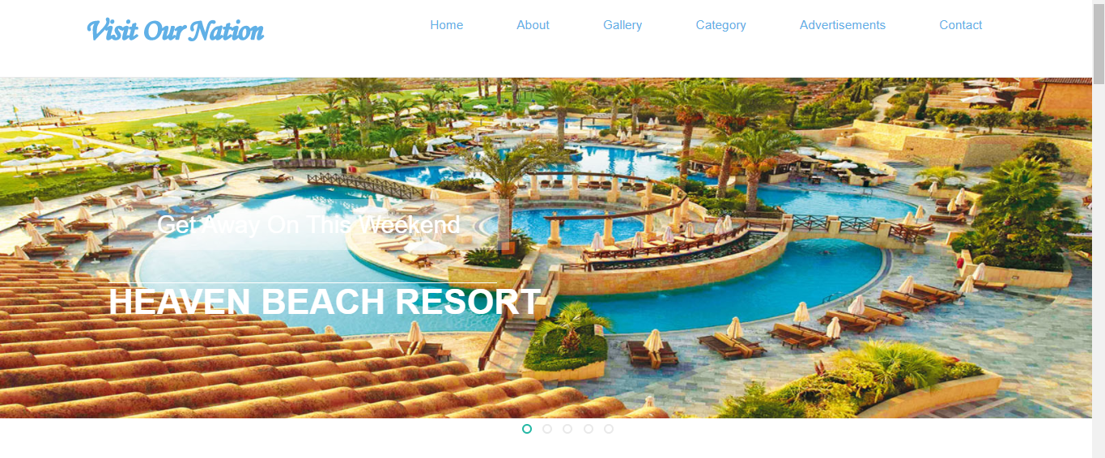

**6.2. About Us**

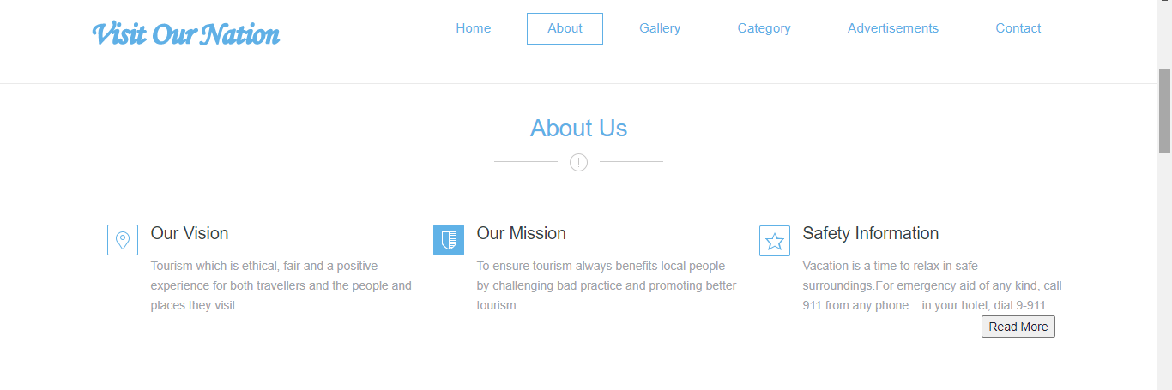

**6.3. Gallery**

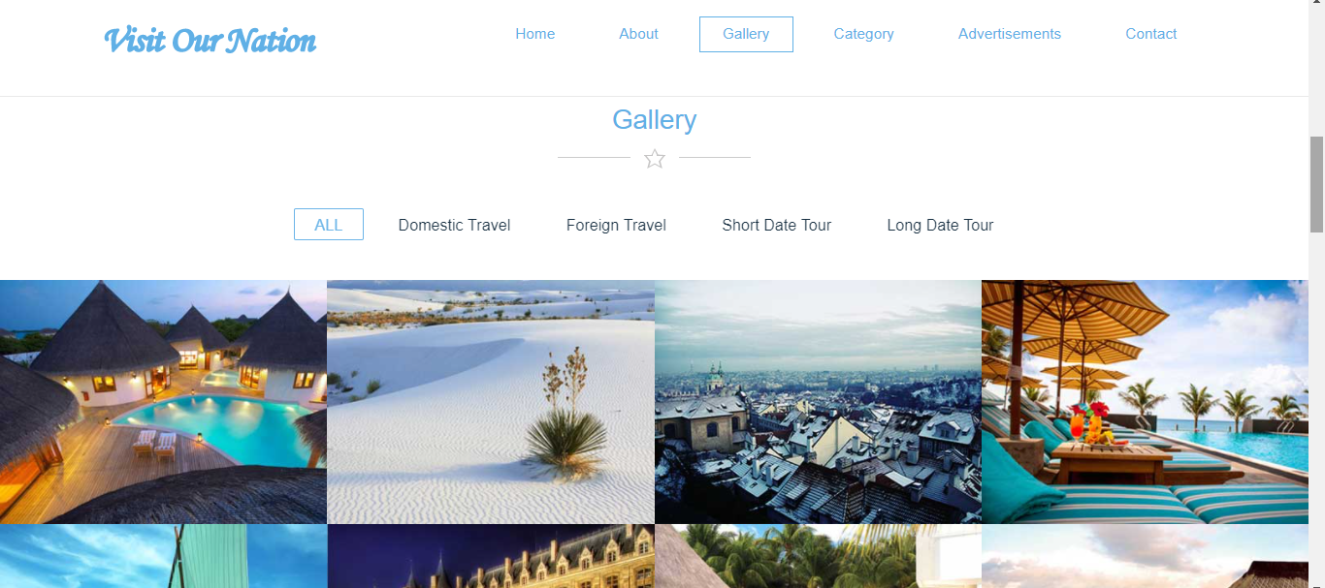

**6.4. Category**

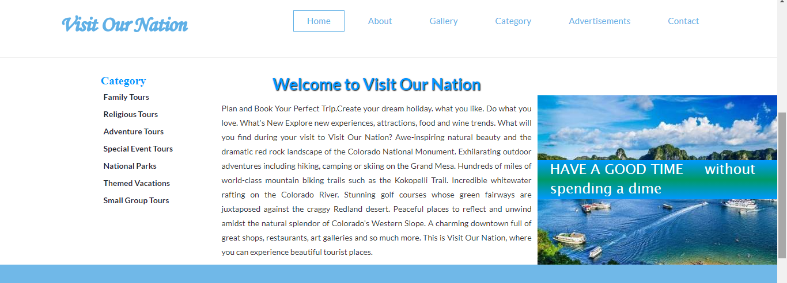

**6.5. Advertisements**

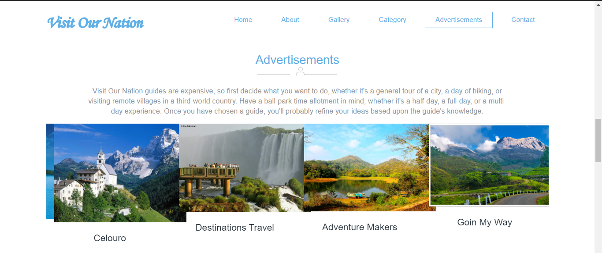

**6.5. Contact**

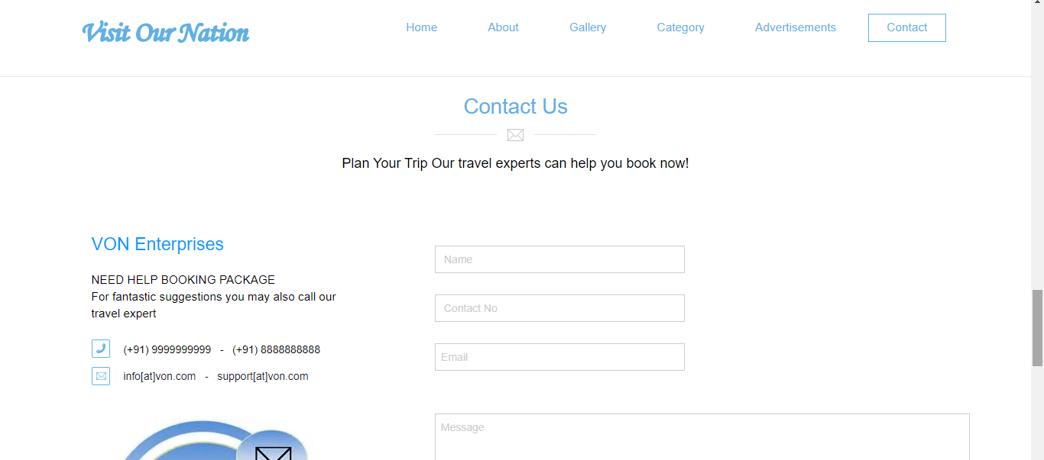

**6.6. Admin Login**

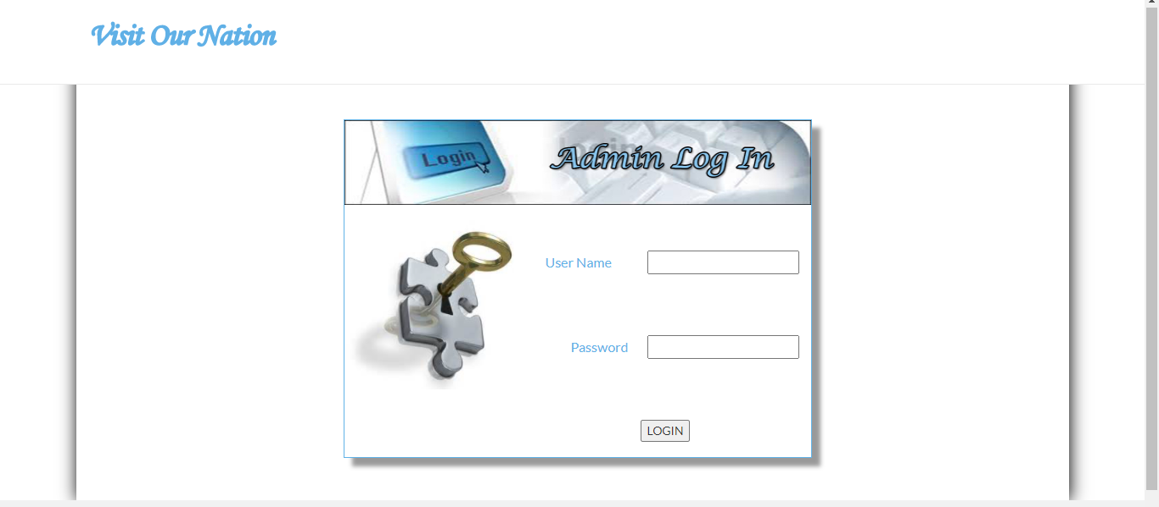

**6.7. Admin Page**

